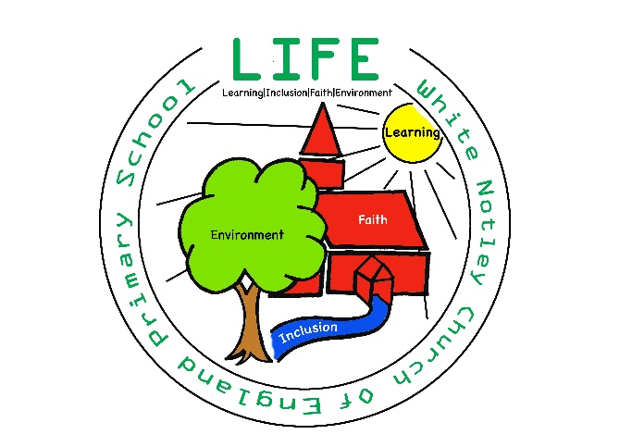

White Notley C of E Primary School
Remote Education Offer

This document is for the school to share relevant information with pupils and parents or carers about how we will provide remote education. This information is published on our school website as required to support understanding of what pupils, parents and carers should expect during periods of school closure or pupil isolation.

Spring 2026

Remote education provision: information for parents
This information is intended to provide clarity and transparency to pupils and parents or carers about what to expect from remote education if local restrictions require entire cohorts (or bubbles) to remain at home.
For details of what to expect where individual pupils are self-isolating, please see the final section of this page.

The remote curriculum: what is taught to pupils at home
A pupil’s first day or two of being educated remotely might look different from our standard approach, while we take all necessary actions to prepare for a longer period of remote teaching.

What should my child expect from immediate remote education in the first day or two of pupils being sent home?
If a bubble is required to shut whilst the children are at school, pupils will be sent home with a learning pack with workbooks for Maths and English and a reading book. This is for pupils to use on day 1 of being sent home whilst teachers transfer the learning to online lessons.
Extra activities in core and foundation subjects will be set on Class Dojo for pupils to access.

Following the first few days of remote education, will my child be taught broadly the same curriculum as they would if they were in school?
We will teach the same curriculum remotely as we do in school wherever possible and appropriate. However, we have needed to make some adaptations in some subjects. For example, in art or DT, the resources or skills being taught may need to be adapted and changed due to resources available to parents at home. In Science, practical investigations may need to be adapted.

Remote teaching and study time each day

How long can I expect work set by the school to take my child each day?
We expect that remote education (including remote teaching and independent work) will take pupils broadly the following number of hours each day:

Primary school-aged pupils | 3 hours a day on average

Accessing remote education

How will my child access any online remote education you are providing?
Live lessons will be available through Zoom. We will provide live Maths, English and Foundation lesson each day. Online activities, worksheets and tasks related to these lessons and other learning will be shared with pupils and parents through Class Dojo.

If my child does not have digital or online access at home, how will you support them to access remote education?
We recognise that some pupils may not have suitable online access at home. We take the following approaches to support those pupils to access remote education:
- If parents do not have access to a device to get online, in the first instance, they must contact the school and we will arrange a device to borrow. We have a DFE allocation of devices to support home learning, which will be used for this.
- We are able to support parents in negotiating data usage for online learning with their internet or phone provider, please contact us for support in this if it is an issue.
- If you are unable to print out the activities posted online, please contact the school and we will prepare a pack for you with the resources and deliver it to your house. We can then collect the pack for feedback whilst delivering the next set of activities to you.

How will my child be taught remotely?
We use a combination of the following approaches to teach pupils remotely:
- live teaching (online lessons)
- recorded teaching (e.g. Oak National Academy lessons, video/audio recordings made by teachers)
- printed paper packs produced by teachers (e.g. workbooks, worksheets)
- textbooks and reading books pupils have at home
- Tasks uploaded to Class Dojo
- suggested websites supporting the teaching of specific subjects or areas, including video clips or sequences
- Independent study on class topics/projects.

Engagement and feedback

What are your expectations for my child’s engagement and the support that we as parents and carers should provide at home?

- We expect all children to engage with online lessons and set tasks where possible on a daily basis and complete as many tasks as they can, bearing in mind the individual family circumstances and work commitment, etc.
- We expect parents to support online learning but not to feel they have to complete every task with their child.

How will you check whether my child is engaging with their work and how will I be informed if there are concerns?
- Class Dojo and emails are monitored during school hours, where comments on work will be brief and encouraging. Pupils will be expected to be seen in and engage with the daily online live lessons where more in-depth verbal feedback can be given.
- Engagement with online learning will be monitored daily and if children are not logging on over the course of a week, the head teacher will be informed a phone call will be made to check whether further support is needed.
- Staff will also be working outside of school teaching hours to prepare lessons and provide feedback.
- If you are working from home or there are other reasons why your child cannot log onto live lessons and Class Dojo throughout the ‘school’ day, please ensure they are accessing work daily at some point.

How will you assess my child’s work and progress?
Feedback can take many forms and may not always mean extensive written comments for individual children. For example, whole-class feedback or quizzes marked automatically via digital platforms are also valid and effective methods, amongst many others. Our approach to feeding back on pupil work is as follows:
- Pupil’s work will be handed in in a variety of ways – through photos and videos uploaded to class Dojo, work activities and sheets uploaded, quizzes, and through presenting ideas and answers and work tasks in live lessons.
- Teachers will respond to all work posted on Class Dojo over the week with positive and encouraging comments. Work may be discussed in live lessons and verbal feedback given. If a more in-depth response is needed, teachers may arrange additional support to go through any ongoing misconceptions.
- Teachers will respond to parent questions and comments sent or posted during the school day: 8am-5pm, and are not expected to reply outside of these hours. The Head teacher is always available via email or Class Dojo if there is an urgent need outside of school hours.

Additional support for pupils with particular needs

How will you work with me to help my child who needs additional support from adults at home to access remote education?
We recognise that some pupils, for example some pupils with special educational needs and disabilities (SEND), may not be able to access remote education without support from adults at home. We acknowledge the difficulties this may place on families, and we will work with parents and carers to support those pupils in the following ways:
- There will be work set via Class Dojo that is at the level of ability appropriate for the young person to complete.
- Live lessons will be ability grouped to support pupil learning where appropriate. A pupil with SEND may be asked to join the lesson early or stay on at the end of the live lessons for extra support or clarity to be given on a task.
- The young person's completion and success of the tasks set will be monitored by the class team.
- There will be regular communication with parents and families from the class teacher and support team, as well as the SENCO, to support the learning of the young person if needed.
- Where needed, additional resources will be provided to aid the young person in completing the tasks set and embedding a greater level of independent learning.
- Where appropriate outside support will be sourced by the school to aid the remote learning for the young person (i.e. Specialist Teaching Teams).
- For those with Education and Health Care plans the Reasonable Endeavours paperwork will be informally reviewed with the SENCo.

Remote education for self-isolating pupils
Where individual pupils need to self-isolate but the majority of their peer group remains in school, how remote education is provided will likely differ from the approach for whole groups. This is due to the challenges of teaching pupils both at home and in school.

If my child is not in school because they are self-isolating, how will their remote education differ from the approaches described above?
Where possible, remote learning for pupils self-isolating will be as laid out above, with the use of CGP workbooks to support tasks and work uploaded to Class Dojo.
When a child is unwell and self-isolating, please let the school office know.

