**Class Four embracing our LIFE vision: Learning, Inclusion, Faith and Environment**

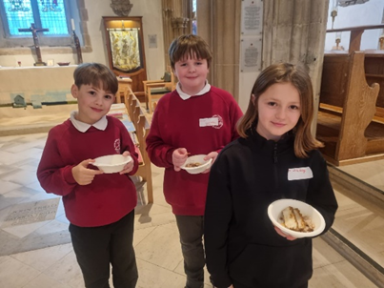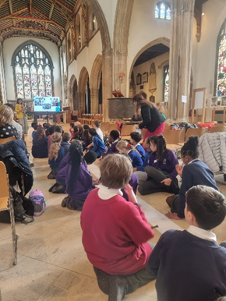At the beginning of the Spring term, some of the children went on the train to Chelmsford Cathedral to join other children in learning about The Windrush and other Journeys.

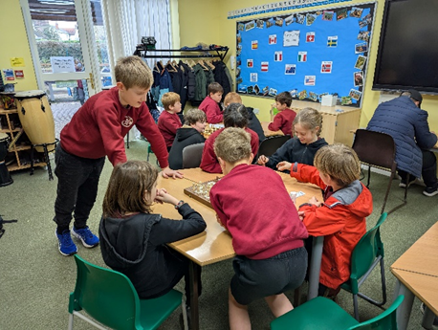

We are proud that some of the children used their initiative and pupil voice to set up and run a chess club, which has been well attended.

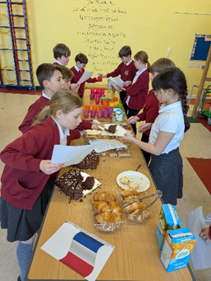

In March, the children were transported to La Café Chicoree, where they took on the roles of customer and server, practising their French. They enjoyed speaking French and eating pain au chocolat and gateau!

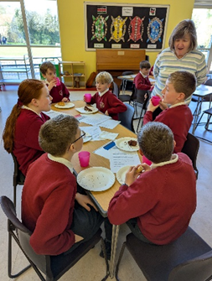

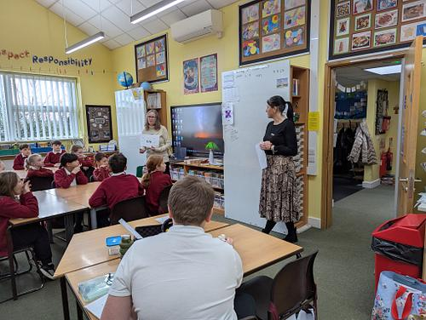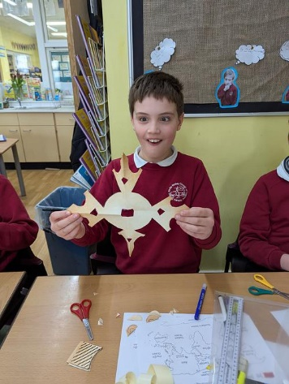 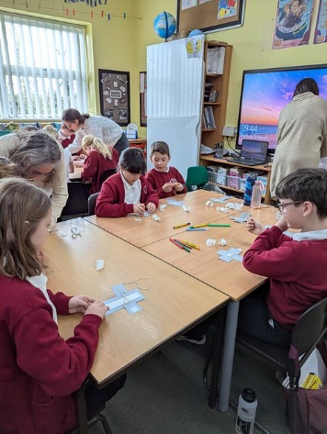

Empower visited the class in March. We had great fun exploring Christian crosses from around the world (ACross The World). On their trip around the world, they explored each country's culture and values and looked at how these influenced the design of the cross. They also explored the theology behind the cross which linked very well with our current RE topic 'What difference does the resurrection make to Christians'.

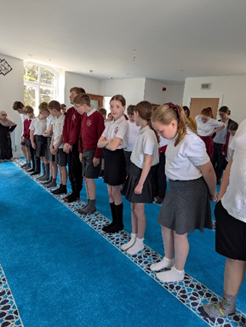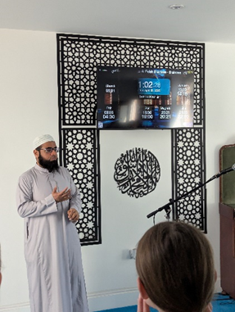In May, Class Four enjoyed an informative and interesting trip to the Braintree Mosque. The children learned a lot about how Muslims worship in the mosque.

We were also very lucky today to have Mr Allen come from London to lead coding workshops using trains and tracks. The children absolutely loved making investigating the randomness of the trains, and coding them to go faster, slower and in different directions to 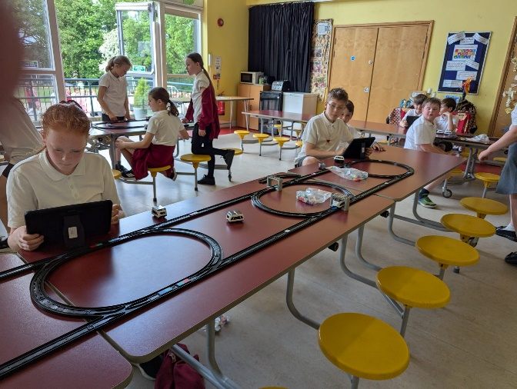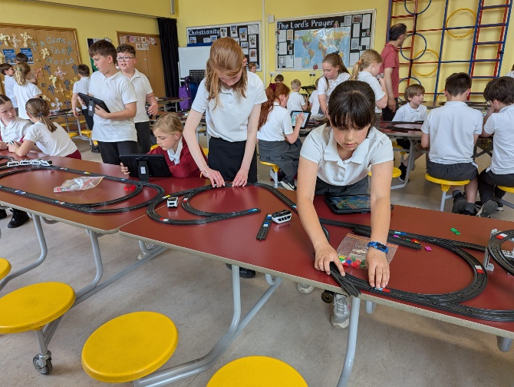avoid crashes!

